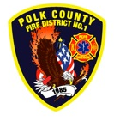**EMS and Logistics Board Report**

Division Chief Frank Ehrmantraut

March 2023

**February’s Events**

I had the privilege to attend FF Norbury’s funeral in Gresham with three of our volunteers. The service was well attended and a respectful tribute to the life and impact of Brandon Norbury.

* Pulseless Person’s Roundtable – Partner discussion on best practices after a field determination of death.
* Regional After Action Review - I5 MVA/MCI near Harrisburg
* Sport Venue Evacuation and Protective Action – 2 day class with a WOU representative on protective action plans for large events
* Network Interface Partner Planning – Network Interface is working actively to increase representation of historically underrepresented populations in Emergency Medical Services.
* Check in with Polk County Public Health regarding EMS needs during a disaster.
* Quarterly “Touch Base” with Salem Hospital and regional EMS providers
* Marion County ASA Meeting
* STEMI Training Night – Salem Hospital hosted a valuable training that was attended by some of our paramedics.
* EMS, Heart & Stroke Virtual Conference – Virtual conference hosted by Providence that was attended by several of our members.
* PreHospital Trauma Life Support – PCFD hosted a grant funded class for other providers in the state. We had six providers attend and receive their certification.
* EMS Data Workgroup – Workgroup to make recommendations to State EMS Committee and Oregon Health Authority regarding state wide quality management activities based on OREMSIS data.
* EMS Drill – Cultural Competency taught by outside facilitator

**Apparatus Updates**

* L91 – The broken platform controls were fixed. Several small things were also evaluated and fixed.
* L91 – Repairs completed after collision with fixed object at WOU
* Kent McKnight, City of Dallas Shops, came by to prioritize a list of maintenance needs. Dallas Shops has plans to increase their capacity and be able to provide more services to the Fire District. If this occurs, we will see a significant decrease in apparatus downtime during maintenance.

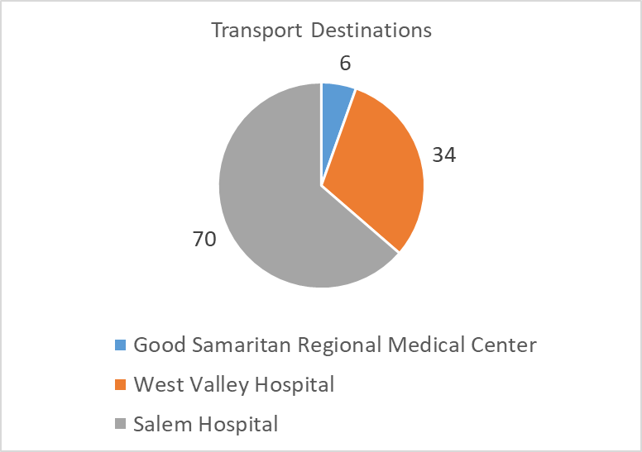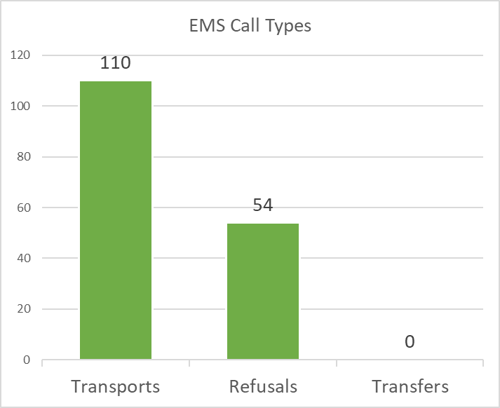**EMS Performance**