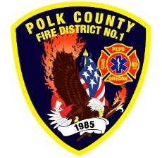Fire Prevention Report

**For Board Meeting, June 12, 2025**

**By Division Chief Fire Marshal Troy Crafton**

**May’s Events** (Plan Review, Inspections, Training, Incident Response)

* 2025 Touch-A-Truck Event
* WOU Block Party
* OFMA Conference in Bend
* TMS Fire Safety class
* 900 N Main Inspection
* 6740 Corvallis Rd driveway
* Cafe Lula Final Inspection
* Fire line Inspection 300 Stadium Drive
* Riddle Road Apartments Fire Line Inspection
* Riddle Road Apartments Sprinkler Inspection
* 18 Plan Reviews
* 3 Smoke Alarm Installs
* Flow MSP set up and Pre-Plans
* Risk Reduction Grant for District Addressing / Preplanning
* 4.5 Hours Fire Marshal Service IGA Dallas Fire Department
* 1.5 Hours Fire Marshal Service IGA Polk County Building Department
* 1 Incident With .5 Hour Of Response

**Upcoming Events** (Plan Review, Inspections, Training)

* Safety Committee Meeting First Tuesday of the Month
* Color Run at MES
* The Thoughts & Gifts Project
* Field Day at IES
* Last Day of School
* MPFIT Meeting

**Activities** (Meetings)

* Safety Committee Meeting First Tuesday of the Month
* Polk County CWPP Meeting
* IAAI meeting
* Food Truck Code Revision
* Fire Code Meeting IGA with Both Cities
* Monthly Officer Meeting
* Monthly Monmouth City Project Meeting
* Monthly Independence City Project Meeting
* Monmouth Building Meeting Every Thursday
* Dallas DRT Meeting Every Thursday