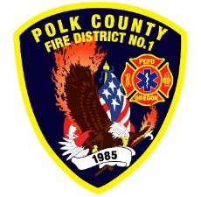
Fire Prevention Report
For Board Meeting, January 12, 2023
By Division Chief Fire Marshal Troy Crafton

December’s Events (Plan Review, Inspections, Training, Incident Response)

- Pub Ed Tree Lighting Parade with L91 and E2 Dec 2nd
- Pub Ed Making Spirits Bright event Monmouth Park Dec 3rd
- Pub Ed Santa Train event Independence Dec 3rd
- OFSM Grant Review Team
- Oregon Smoke Alarm Install Webinar
- Community Wildfire Risk Reduction Grant Clinic
- Hydrant Test 527 Jackson
- Riddle Road Apartments Fire Line Inspection
- YMCA License Inspection
- 22 Building Inspections
- 9 plan reviews
- 2 Driveway Inspections / Address signs
- 1 Smoke alarm Installs
- Out station inspections
- Mapping and Addressing Project with cities and county
- Rural Water Supply project With Polk County
- Plan review project With Monmouth and Independence
- 30 incidents with 18.3 hours of response

Upcoming Events (Plan Review, Inspections, Training)

- Monmouth City Project meeting Jan 12th
- Community Wildfire Risk Reduction Grant Clinic Jan 12th
- OLST Meeting Jan 19th
- Oregon Fire Service Capacity Program Review Committee Jan 25th

Activities (Meetings)

- OFSM meeting Dec 1st
- MPFIT Meeting Dec 6th
- Monmouth City Project meeting Dec 8th
- OFSM Grant meeting Dec 16th

