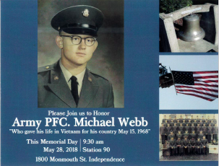
Polk No. 1 honors veteran
INDEPENDENCE — Polk County Fire District No. 1 will hold a brief ceremony at 9:30 a.m. on Monday in memory of Michael Webb, a Central High School graduate and Vietnam veteran who was killed in action on May 15, 1968, 50 years ago.
Michael was the son of Assistant Chief Bill Webb from the City of Monmouth Fire Department.
The fire bell from the City of Monmouth was dedicated to Michael on July 4, 1984. The bell is now located at Polk County Fire District No.1’s fire station in Independence, where the memorial will be held.
His surviving sister, Mary Jo Allison, of Dallas, and former Monmouth Fire Chief, Don Milligan, will be in attendance.

