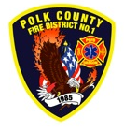**EMS and Logistics Board Report**

Division Chief Frank Ehrmantraut

January 2022

**December’s Events**

* Chemeketa EMS Program Advisory Meeting
* After Action Review with Medical Examiner
* First Aid/CPR Class taught to Independence Public Works
* OFCA EMS Section Meeting
* Marion County ASA Analyst Ride Along
* First Aid/CPR Class for community members
* Radiological Emergencies Class: OSU’s Nuclear Reactor Orientation
* EMS Drill - Airway Management and Skills

**Apparatus Updates**

* M477 – Routine Maintenance/Oil Change
* Studs placed on duty/staff rigs
* R436 – Air Leaks Fixed

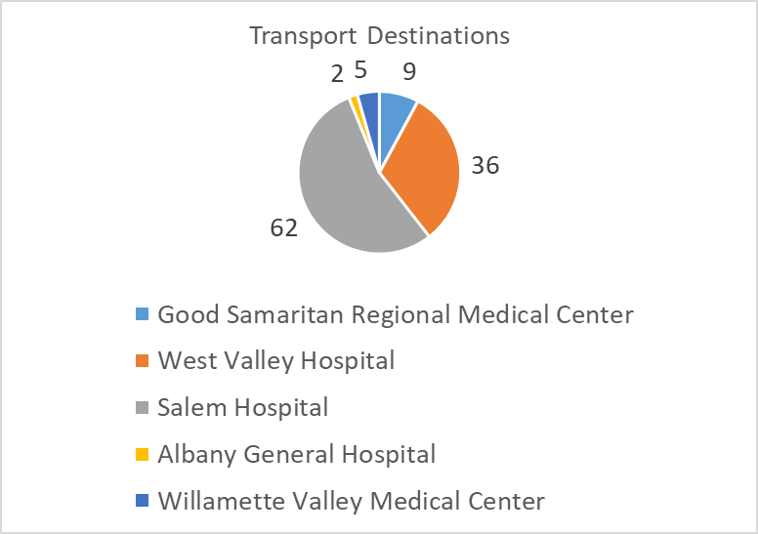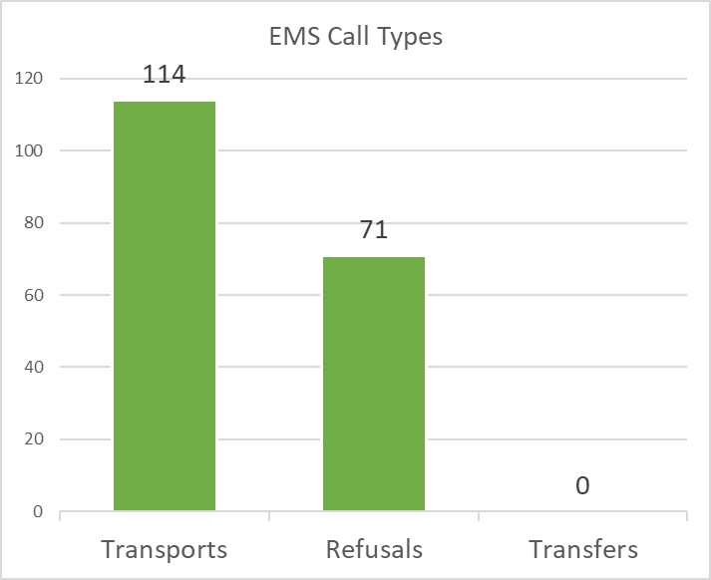**EMS Performance**

