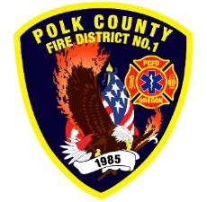
Fire Prevention Report
For Board Meeting, December 14, 2023
By Division Chief Fire Marshal Troy Crafton

November’s Events (Plan Review, Inspections, Training, Incident Response)

- Cornerstone Church PUB ED Nov 15th
- Polk Resource Center Sprinkler Inspection
- Ron Wilson Propane Tank Inspection
- Ron Wilson Final Inspection
- Monmouth Montessori License Inspection
- 719 Jackson St Monmouth License Inspection
- WOU Child Care License Inspection
- YMCA Henry Hill License Inspection
- 30 Business Inspections
- 2 Knox Box Install
- 11 Plan Reviews
- 3 Smoke Alarm Installs
- Active 911 Prep
- Station Holiday Lights
- District Addressing / Preplanning
- Plan Review IGA Planning With Monmouth And Independence Building Departments
- 3.5 Hours Fire Marshal Service IGA Dallas Fire Department
- 8 Incidents With 5.25 Hours Of Response

Upcoming Events (Plan Review, Inspections, Training)

- Fire Extinguisher and Evacuation Training Manuia Adult services Dec 8th
- Fire safety Talmadge Middle School Dec 11th and 12th
- Monmouth City Project Meeting Dec 14th
- Officer Meeting Dec 18th
- Dallas DRT Meeting Every Thursday

Activities (Meetings)

- Monmouth City Project Meeting Nov 9th
- CWPP Meeting At EOC Nov 15th
- Juvenile Fire Setter Intervention Network Nov 20th
- OLST Meeting Nov 28th
- Dallas DRT Meeting Every Thursday

