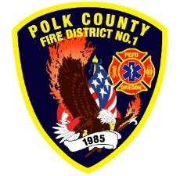
Fire Prevention Report
For Board Meeting, March 9, 2023
By Division Chief Fire Marshal Troy Crafton

February’s Events (Plan Review, Inspections, Training, Incident Response)

- PUB ED Feb 2nd
- PUB ED Feb 17th
- Sing Fay Final
- TOC for Sing Fay Restaurant
- YMCA in Monmouth Consult
- Airport Inspection
- Vista Ridge Apartments inspection
- 19 Plan Reviews
- 2 Smoke Alarm Installs
- Out Station Inspections
- OFSM Grant Review Team
- Mapping and Addressing
- Rural Water Supply
- Plan Review Project with Monmouth and Independence
- 10.5 hours Fire Marshal Service IGA Dallas Fire Department
- 5 incidents with 5 hours of response

Upcoming Events (Plan Review, Inspections, Training)

- Oregon Fire Service Capacity Program Review Committee Mar 1st
- Monmouth City Project Meeting Mar 9th
- Dallas DRT meeting every Thursday

Activities (Meetings)

- Monmouth City Project Meeting Feb
- Dallas DRT Meeting Every Thursday
- Meeting with Monmouth Building Official
- Pre-app for Ash Creek PUD
- MPFIT Meeting

