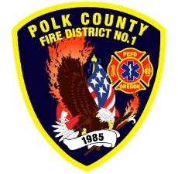
Fire Prevention Report
For Board Meeting, July 13, 2023
By Division Chief Fire Marshal Troy Crafton

June’s Events (Plan Review, Inspections, Training, Incident Response)

- PUB ED At Independence Park 200 kids
- PUB ED At WOU CDC Park 60 kids
- PUB ED Station tours
- Active Threat Drill
- Final at New Diner on Main Independence
- Jackson Apartments Sprinkler Inspections
- WOU Sprinkler Inspections
- Monmouth City Hall Hydro Test
- New York Squares Food Truck Inspection
- Knox Box Install
- 18 plan reviews
- 5 Building Inspections
- 3 Smoke Alarm Installs
- Mapping and Addressing
- Rural Water Supply
- Plan Review IGA Planning with Monmouth and Independence
- 9.5 hours Fire Marshal Service IGA Dallas Fire Department
- 6 Incidents with 8 hours of Response

Upcoming Events (Plan Review, Inspections, Training)

- Community Wildfire Risk Reduction Grant kick off July 11th
- Monmouth City Project Meeting July 13th
- Monmouth Mobile PUB ED July 19th
- Dallas DRT Meeting every Thursday

Activities (Meetings)

- Pre-App Meeting Monmouth June 1st
- MPFIT Executive Meeting June 7th
- Monmouth City Project Meeting June 8th
- Dallas DRT Meeting every Thursday
- Last Day of School Party June 12th
- Safety Meeting Monmouth Micro Community June 14th
- Pre-App Meeting Monmouth June 19th
- Court June 20th

