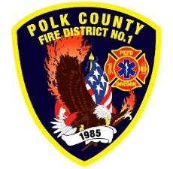
Fire Prevention Report
For Board Meeting, May 9, 2023
By Division Chief Fire Marshal Troy Crafton

April’s Events (Plan Review, Inspections, Training, Incident Response)

- MPFIT Fire Investigation Class at Keizer Fire Department April 1st and 2nd
- PUB ED at CHS 200 kids April 6th
- Fire Safety Training 126 kids at Talmadge April 10th and 11th
- Live Fire Training with Keizer Fire Department April 14th
- Oregon Fire Service Capacity Program Review Committee April 17th
- OSFM’s Community Risk Reduction and Defensible Space Programs Webinar April 18th
- Home Hardening 101 Webinar April 20th
- Final at 1565 Stryker Rd
- Final at 445 Gwinn St
- Knox Box Installs at Central Schools
- Pre-app meeting Independence April 26th
- 18 plan reviews
- 12 Building Inspections
- New Red Cross Smoke Alarm Program setup
- 1 Smoke Alarm Installs
- 6 Driveway Inspections
- Out Station Inspections
- Mapping and Addressing
- Rural Water Supply
- Plan Review IGA Project With Monmouth and Independence
- 10.5 hours Fire Marshal Service IGA Dallas Fire Department
- 5 incidents with 3 hours of response

Upcoming Events (Plan Review, Inspections, Training)

- Monmouth City Project meeting first Thursday
- Dallas DRT meeting every Thursday

Activities (Meetings)

- Oregon Fire Service Capacity Program Review Committee April 17th
- MPFIT Meeting April 18th
- Monmouth City Project meeting first Thursday
- Dallas DRT meeting every Thursday
- Meeting with Monmouth building official
- Meeting with Independence building official
- Meeting with Public Safety at WOU

