SDAO - SPECIAL DISTRICTS ASSOCIATION OF OREGON
Highlighted our Fire Chief, their new Board Member, in the January 2019 Newsletter!

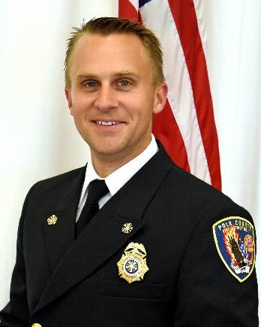
Ben Stange, SDAO Board Member
What role do you serve at your special district and how long have you been with them?
I've been with Polk Co Fire District No.1 since 2000. I've been the Fire Chief since August of 2016. The job of the Fire Chief was never what I set out for. I've served in nearly every other position since 2000 when I joined the District. I've gone from Volunteer Firefighter to Volunteer Lieutenant to Resident Volunteer to Firefighter/Paramedic and a Union President to Captain to eventually to Fire Chief.
How did you get involved with your special district?
I was a student at Western Oregon University. Growing up in Portland I never thought much about the fact that there were volunteer fire departments and was surprised to learn that I could volunteer if I was interested. I did and I met incredible people and couldn't believe the impact I could have.
Why did you seek to join the SDAO Board of Directors?
When I started as a fire chief, I had no idea what I had no idea about. I relied so heavily on SDAO to make sure that we didn't miss a step. I wanted to join the board to make sure that those districts, particularly those that are small, going through change, or don't have a full time staff to support them, can still enjoy the support systems that we all depend on.
What excites you most about SDAO?
This is an exciting time for special districts. For years they have been ignored with laws focused more on cities and counties. Currently, there are a handful of states that are taking the fight for special districts beyond their states and to the federal government. The most incredible part of this is that Oregon (SDAO) is the leader! There is no doubt that as these relationships mature every one of us will benefit.
How has SDAO helped you or your district?
I've made an uncountable number of formal and informal inquiries to SDAO. Without them I would have been shooting from the hip with so many decisions I've faced.
Tell us about your life outside of your day job(s).
My wife and I run a lot. Our "dates" typically consist of getting a babysitter to watch the kids so we can run for a couple hours to prep for our next marathon. We have 3 boys (8, 5, and 1) who we travel the state with in our Volkswagen Vanagon. They get incredibly excited at every stop seeing everything there is to offer in every corner of the state. We have literally passed through nearly every special district in the state of Oregon.

SDAO Newsletter - Jan 2019

